

**FINAL REPORT**

ON

**CONVERSIONS IN NUMBER SYSTEM**

**(BINARY OCTAL DECIMAL HEXADECIMAL)**

COURSE CODE: INT213 (PYTHON PROGRAMMING)

SUBMITTED BY: GROUP 2

SECTION: K19CD

Date:November 3,2020

**SUBMITTED BY:**   **SUBMITTED TO:**

K19CDA10 Rahul Kumar 11902579 Mr. Ishan Kumar

K19CDA18 Shivam 11902376

K19CDA23 Amir Nesar 11902449

1

**Student Declaration**

This is to declare that this report has been written by us. No part of the report is copied from other sources. All information included from other sources have been duly acknowledged. We aver that if any part of the report is found to be copied,we are shall take full responsibility for it.

**Rahul Kumar 11902579**

**Shivam 11902376**

**Amir Nesar 11902449**

**Lovely professional University**

2

**Abstract**

The objective of our project is to create a number system conversion from one system to another system( binary, octal ,decimal ,hexadecimal ) with the help of GUI a python program or code. We start looking for the requirements from the project and start learning from the resources like The official Python Tkinter tutorial this helps us in learning tkinter with some applicationlikework with widgets ,such as buttons and text boxes ,in controlling our application layout with geometry managers and making our applications interactive by associating button clicks to Python functions.We looked from some particular websites like geeksforgeeks , programiz.com for seeing some functions need to be included in the program.We look in tkinter 8.5 reference also which is a GUI for Python is an extensive reference covering the majority of the Tkinter module. It’s exhaustive, but it’s written in the reference style without commentary or examples.From the above references we learnt all the requirement for this project and divides the work among ourselves to perform this project.We decided each of our task to be done separately and then combining these modules to complete the whole task.As, a result we completed the given task in the given amount of time and in while making this project we get to know about various applications that can be performed or made with the help of the functions which we study in python programming language and we learnhow to work with widgets ,such as buttons and text boxes ,in controlling our application layout with geometry managers managers and making our applications interactive by associating button clicks to Python functions.So this project helps us in learning and motivating to made some more real life applications.

3

**Acknowledgements**

We have taken efforts in this project. However, it would not have been possible without the kind support and help of Mr.Ishan Kumar teaching us python programming in this semester.We would like to extend our sincere thanks to our sir.

We are highly indebted to Ishan Kumar sir for their guidance and constant supervision as well as for providing necessary information regarding the project and also for their support in completing the project.

We would like to express my gratitude towards our parents who always motivates us while doing this project.

We would like to thank Lovely Professional University to design and includes such types of projects in every semester.

4

**Contents**

1.Introduction ………………………………………………………….. 6

a)Overview …………………………………………………………….. 6

b)Parameters in the project …………………………………………….. 6-7

2.Description of module ……………………………………………….. 7-8

2.Project Contribution …………………………………………………. 9

a) Material and methods ……………………………………………….. 9

b)Distribution of work …………………………………………………. 9

c)Results ……………………………………………………………….. 10

d)Discussions ……………………………………………………………10

3)References ……………………………………………………………. 11

**Introduction**

We have created a Number system conversion calculator which allows the user to enter a number in any one Number system ( binary, octal, decimal, hexadecimal ) to the remaining three. It is very simple to use the user just needs to select the base first and then entering the number to be converted to other base.

**Overview**

**How To Run The Project?**

To run this project, you must have installed any application which allows you to run python code on your system. After downloading the project, you have to follow the steps below:

Step1: Extract/Unzip the file

Step2: Thus, Go inside the project folder, open and enter to start the system. The design of this project is pretty simple so that the user won’t find any difficulties while working on it, you can copy the code and run it.

**Parameters used in this project are as follows:**

**Python**

Python offers multiple options for developing GUI (Graphical User Interface). Out of all the GUI methods, tkinter is most commonly used method. It is a standard Python interface to the Tk GUI toolkit shipped with Python. Python with tkinter outputs the fastest and easiest way to create the GUI applications. Creating a GUI using tkinter is an easy task.

We have created a GUI based calculator for conversion of base of a number in a different Number system.

**Tkinter**

Tkinter is the standard GUI library for Python. Python when combined with Tkinter provides a fast and easy way to create GUI applications. Tkinter provides a powerful object-oriented interface to the Tk GUI toolkit. Creating a GUI application using Tkinter is an easy task. All you need to do is perform the following steps

6

To create a tkinter :

1. Importing the module – tkinter

2. Create the main window (container)

3. Add any number of widgets to the main window

4. Apply the event Trigger on the widgets

**Description Of Module**

As we can see from the below diagram the main layout of the conversion calculator is show we can see the steps as well i.e choose a base for the given number ,enter the number simply.

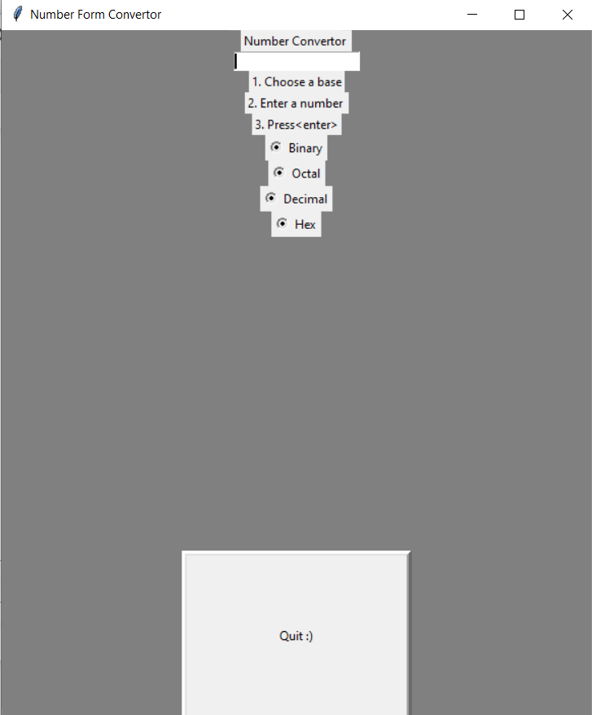

From the below diagram you can see the number entered by the user is 1001001 in binary as the result for the rest is shown in all the remaining three bases.

So, it is very simple to use for the user just need to follow the steps ,if you don’t select any base or choose more than one it will give error message to select a base and at the end simply select the quit button to exit the conversion calculator.

7

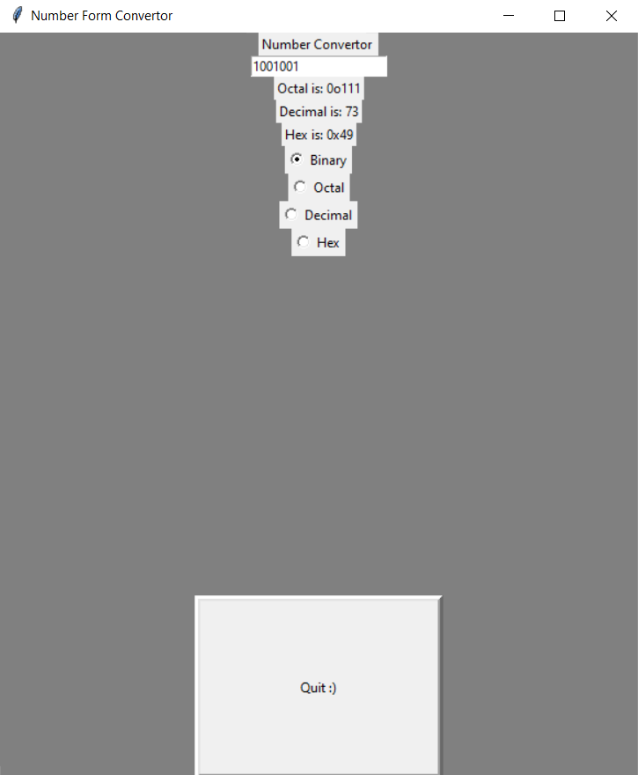

To make it more comfortable for the user to understand the concept we add a explanation button which allows user to see the calculations manually also.

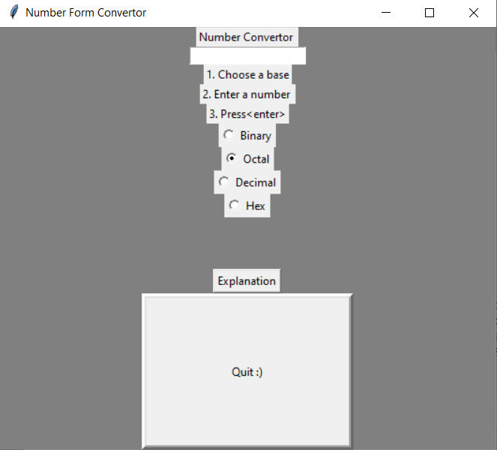

If the user will click on the explanation button he can see the concepts of the conversion like below decimal to binary is shown .

8

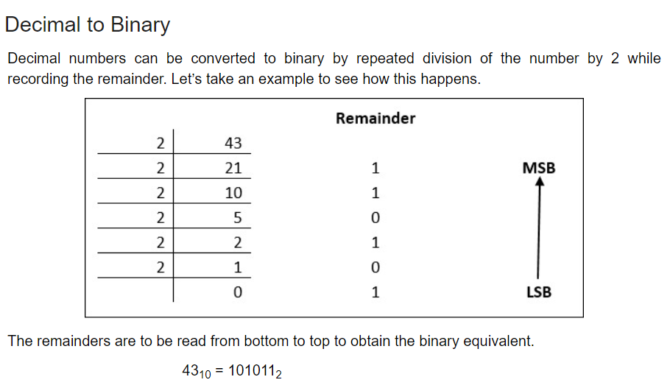

**Project Contribution**

**Material and methods**

For the coding purpose we have used Jupyter Notebook application which allow us to create edit documents that display the input and output of a python code. Python offers multiple options for developing GUI. Out of all the GUI methods, tkinter is most commonly used method. It is a standard Python interface to the Tk GUI toolkit shipped with Python. Python with tkinter outputs the fastest and easiest way to create the GUI applications. Creating a conversion of number system using tkinter was an easy task.

**Distribution for work**

We simply divides the work between us Rahul is focusing on the page or window layout, Shivam was working on the functions and Amir working on the responsiveness of the number system conversion calculator and at the end all of us one by one look for the changes if needed and verification was done individually.

With the help of official Python Tkinter tutorial we get the idea how to approach this project and present it in a good manner.

9

**Results**

After successfully attempting this project we find that using this GUI application in python we can easily create a number system conversion calculator and tkinter allows us to make it and present it in a good manner.

We also get motivated after successfully attempting this project to make and try for some more applications which are needed and beneficial for us.

**Discussions**

At the starting we all are aware and comfortable with python programming and we were aware with tkinter and GUI applications but to properly implementing this project we decided to take help from some online platforms we take help official Python Tkinter tutorial which gives the idea to us how to approach the project.We look in for some websites also like geeksforgeeks , programiz.com for some help.

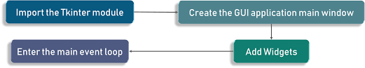

After completing this project we get more clarity in this topic and we were motivated to work on some new projects also to create more applications with the help of python programming.

10

**References**

Here are some official resources to check out:

1. The official Python Tkinter tutorial helps in get started with tkinter with some application **,**work with widgets ,such as buttons and text boxes ,in controlling our application layout with geometry managers and making our applications interactive by associating button clicks to Python functions

2. Tkinter 8.5 reference:It is a GUI for Python is an extensive reference covering the majority of the Tkinter module. It’s exhaustive, but it’s written in the reference style without commentary or examples.

3. Some specific websites like geeksforgeeks ,programiz.com which gives a clear idea for a particular function to be included in the code or the logic behind the function needs to be included in the coding part.

11